The Fun in Play: Independence, Assistance, Effort and Difficulty

Abir Mullick, Gourab Kar and Sarah Endicott,

ABSTRACT
The purpose of this study was to learn from children about important aspects of inclusive indoor play and what makes it fun. Researchers observed how children with and without disabilities interacted with a variety of playthings in a full-scale play environment and investigated the impact of independence, assistance, effort, and difficulty on fun at play. Results suggest that children perceive fun as a combination of some level of dependence, requiring some level of assistance, an increased level of effort, and some level of difficulty in play.

KEYWORDS:
Play; Inclusive Indoor Play; Children; Fun

BACKGROUND
Fun is integral to play and the extent to which children engage in play is directly dependent on the level of perceived fun. Even though most games have been developed so that users have fun, very little is known about the play elements that create the perception of being fun [1]. The results of a study that facilitated peer relationship building through play concluded fun as an essential element for play [2].
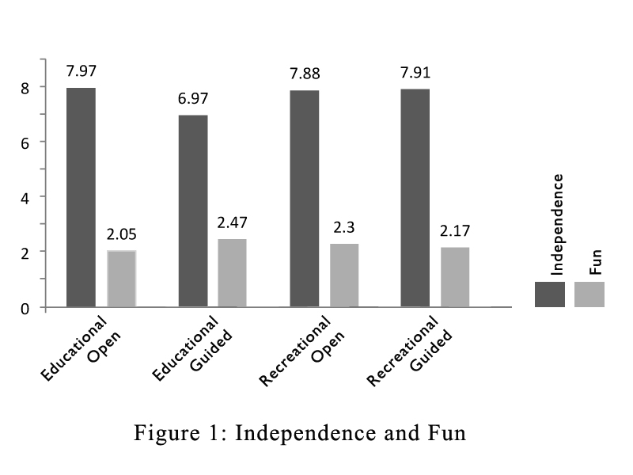
Historically, children with disabilities have been at a distinct disadvantage when it comes to play. For example, mobility problems make it difficult, if not impossible, for children to play hide and seek. Visual impairments impede an infant’s ability to find and investigate play environments, while cognitive disabilities limit development of pretend play. In fact, any disabilities pose barriers to spontaneous engagement in play and play environments [3]. The play repertoires of children with disabilities are reportedly more limited, their play is more often passive and sedentary [4], and their play occurs less frequently [5], [6]. Additionally, their play is more often solitary [7], [8], social interaction is frequently delayed or distorted, and symbolic play is often significantly limited [9], [10].
The Play Study is a part of the Inclusive Indoor Play project that researched indoor play environments to develop universal play environments. This study employed a full-scale play environment to systematically model and research human performance. The indoor play environment allowed comparing play behaviors and conducting human factors research on accessibility, playability and user-participation.
In addition to researching the play needs and preferences of children with and without disabilities, the Play Study investigated how children perceived fun in play. In particular the study researched the impact of independence, effort, assistance and difficulty on fun. The research questions for the study included:
- What is the relation between independent play (a child’s ability to play independently) and fun?
- How is fun influenced by effort (level of work involved in play)?
- Is there a relation between assistance (the extent to which help is received) and fun?
- How is difficulty (hardship in play) connected to fun?

METHODS
The study was conducted in an indoor play laboratory equipped with a wide range of playthings. The laboratory was equipped with computer-controlled cameras to record play actions and voice. Subjects could be observed within the play lab or through the recording system from another room. All children were recorded as they played, and video and interview results were used later to analyze five aspects of play – independence, effort, assistance, difficulty and fun.
The room was furnished with a soft, interlocking floor, child size table and chairs, and playthings. Sixteen playthings, which represented four play types, were used for the study. An easel, magnetic alphabets, visual puzzle and Leap Pad represented educational / guided play; building blocks, role play set, train set and musical instruments represented educational / open play; gears, ball popper, marble race and mighty loader represented recreational / guided play; and slide, ball pit, sand table and tunnel represented recreational / open play.
Eighteen children ages 5 to 8 years were recruited for the study. Of the 18 children, 8 were male, and 10 female; 10 were white, 7 African American, and 1 Asian. Fifteen children had disabilities, 3 did not, and of the 15 children with disabilities, 5 used a wheelchair, and 11 had mild to moderate cognitive impairments. Determination of level of cognitive impairment was based upon parental report.
Each child was directed to play with 4 playthings, one from each of the play types. The playthings were randomized, so each child played with a different grouping of playthings. After playing with each of the playthings, children were interviewed for their opinions about the difficulty in play, and fun. Although play sessions were not time limited, they lasted approximately one hour.
Data coding followed a benchmarking system where the videotaped information was first coded independently by two project researchers, then compared for similarities and discrepancies. Any discrepancies in the information coding were discussed and resolved. This method of co-coding ensured uniformity in data interpretation and a level of reliability in data tabulation.
Independence in play was measured using a 10-point Playability scale, with (10) being completely independent and (1) being completely dependent at play. Level of assistance and effort were measured using a 5-point Assistance and Effort scale respectively. For level of assistance needed, (1) indicated no assistance needed to (5) indicating refusal to try. For effort, (1) indicated minimal effort required and (5) indicating refusal to try. Difficulty and fun were measured using a 3-point Difficulty and Fun scale respectively. On the difficulty scale, (1) indicated easy to play, and (3) not easy to play. For fun scale, (1) indicated not fun to play, and (3) indicated fun to play. Project researchers using the videotaped information rated independence in play, level of assistance and effort required to play. Level of difficulty and fun were reported by children and obtained by interview.

RESULTS
The data from the play study was coded according to the scales described in the previous section. Subsequently, the codified data was analyzed to understand the significance of the information and derive findings from it. There were four different analyses done on the data: Fun and Independence; Fun and Assistance; Fun and Effort; and Fun and Difficulty. Due to the small sample size, rigorous statistical methods were not deemed to be appropriate for the data interpretation. The results of researcher interpretation (independence, assistance, effort) and child opinion (difficulty, fun) for playthings in the four play types were plotted in the form of a bar graph to understand the correlations between fun and the other four play variables. Analysis of the results shows: 1) Higher independence correlates low fun (Fig 1); 2) Fun increases with assistance (Fig 2); 3) Strong correlation between fun and effort (Fig 3); and 4) Fun corresponds with difficulty (Fig 4).

DISCUSSION

Independence and Fun (Fig 1)
Results show a strong correlation between independence and fun. Children within the age range of 5-8 years perceive dependence in play as fun. The level of independence did not impact the level of fun in all play types, and all children regardless of their disabling condition, enjoyed some level of dependence.
Unlike adults who value independence and self-reliance, children perceive dependence as collaboration and hence it is valued and desired. There is very little difference in the perception of dependence among children with and without disabilities, and dependent play is fun and enjoyable to them.
The results of the study show even though children who use wheelchair are more dependent than those who do not, the level of fun remains constant among both groups of children. This establishes that dependence is an important play component for fun and all children enjoy it equally. The results also show that both children without disabilities and those with minimal level of cognitive impairments experience play dependence. And those with moderate level of cognitive impairments are reliant on a much higher level of dependence than who are not. However, dependence produces same level of fun for all children.

Assistance and Fun
Results show that fun increases with assistance and children perceive play assistance as fun. The assistance level did not impact the fun in all play types, and all children regardless of any disabling condition, enjoyed assistance.
Children see assistance as a desirable play quality and it offers opportunities to collaborate and interact with other participants. For children with and without disabilities there is little difference between assistance and fun, and assisted play is fun for them.
The results of the study show children who use wheelchairs need more play assistance than those who do not, and regardless of the assistance level both groups of children have same level of fun. Clearly, assistance is an important aspect of play and it promotes play interaction. The results also show that both able-bodied children and those with mild to moderate level of cognitive impairments are reliant on assistance, and regardless of the level of impairments, they all have same level of fun.

Effort and Fun
Results show there is a strong correlation between effort and fun. Children associate effort with fun, and it explains the need for physical rigor in play, without which play can lead to monotony and boredom. The level of effort did not impact the fun level in all play types, and all children regardless of their disabling condition, enjoyed some play effort.
Figure 1: Independence and Fun
Figure 2: Assistance and Fun
Children perceive effort as physical rigor needed to engage in play. Hence it is appreciated and cherished. Through play effort, children find opportunities to move from one play level to another and enjoy the outcome. There is very little difference in the perception of effort among children with and without disabilities, and effortless play is devoid of fun and enjoyment.
The results of the study show that children who use wheelchair exert more effort than those who do not to enjoy the same level of play fun. This establishes the need for effort in play, and it must match with the capabilities of the children. Play with uniform level of effort will encourage some children and dissuade others. The results also show that different level of effort is needed by children without disabilities and those with mild to moderate level of cognitive impairments; less effort for children without disabilities and more for children with mild to moderate level of cognitive impairments. However, regardless of their cognitive impairments, all children enjoy same level of fun.

Difficulty and Fun
Results show that fun increases with difficulty and children perceive play difficulty as problem solving and hence fun. The difficulty level did not impact the fun in all play types, and all children regardless of their disabling condition, enjoyed some difficulty.
Children who use wheelchair experience higher level of play difficulty over those who do not. However, they have same level of fun. Clearly, difficulty is an important aspect of play and for children who use wheelchair is an important source of fun. Both children without disabilities and those with mild to moderate cognitive impairments experience play difficulty and regardless of their impairments they all enjoy same level of fun.

Figure 3: Effort and Fun

Figure 4: Difficulty and Fun

CONCLUSIONS
The investigation reported here represents an important step towards understanding the importance of fun in inclusive indoor play. Clearly, children find fun in dependence, assistance, effort and difficulty. Due the differences in children, the level of independence, assistance, effort and difficulty must be varied to suit their individual abilities and preference. For an inclusive play environment to offer fun, it must offer a combination of some level of dependence, requiring some level of assistance, an increased level of effort, and some level of difficulty in play.

ACKNOWLEDGEMENTS
This research was supported by grant # H133G040250 from the National Institute on Disability and Rehabilitation Research (NIDRR), U.S. Department of Education.

REFERENCES
- Choi, D., Kim, H., and Kim.J. (1999) Toward the construction of fun computer games: Differences in the views of developers and players. The Journal of Personal and Ubiquitous Computing, Volume 3, Number 3.
- Poris, M. (2005) : Understanding what fun means to today’s kids . Young Consumers: Insight and Ideas for Responsible Marketers, Volume 7, Number 1, 2005, pp. 14-22(9)
- Lane, S. J., & Mistrett, S. G. (1996). Play and assistive technology issues for infants and young children with disabilities: A preliminary examination. Focus on Autism and Other Developmental Disabilities, 11 (2), 96-104.
- Florey, L. (1971). An approach to play and play development. The American Journal of Occupational Therapy, 25 (6), 275-280.
- Krawkow J.B. & Kopp, C.B. (1983). The effects of developmental delay on sustained attention in young children. Child Development, 54, 1143-1155.
- Li, A. K. F. (1981). Play and the mentally retarded. Mental Retardation, 19, 121-126.
- Bergen, D. (1991). Play as the vehicle for early intervention with at-risk infants and toddlers. ERIC Document Reproduction Services, ED 335115.
- Jennings, K.D., Connors, R.E., Stegman, C.E., (1988). Does a physical handicap alter the development of mastery motivation during the preschool years? Journal-of-the-American-Academy-of-Child-and-Adolescent-Psychiatry, 27(3): 312-317.
- Missiuna, C., & Pollock, N. (1991). Play deprivation in children with physical disabilities: The role of the Occupational Therapist in preventing secondary disability. The American Journal of Occupational Therapy, 45(10), 882-888
- Bergen, D. (1991). Play as the vehicle for early intervention with at-risk infants and toddlers. ERIC Document Reproduction Services, ED 335115.

